Lab 1: **Create Virtual Network and Subnet**

1. **Create Virtual Network (By default namespace is 10.0.0.0/16)**

Search 🡪 Virtual network 🡪 +Create 🡪

1. **Next 🡪 Next 🡪** Observe the default address range and default subnet.
2. **Review + Create** 🡪 **Create.**

**Add one more subnet.**

1. **Select DemoVnet** 🡺 **Subnets** 🡪 **+ Subnet**

1. **Select DemoVnet 🡪 Diagram (Under Monitoring)**

**Lab2: Create Network Security Group (NSG) and associate with FrontEnd Subnet**

1. Create **NSG** for Frontend

Search 🡪 Network Security Groups 🡪 + Create

**🡪 Review + Create**

1. **Associate the NSG to the FrontEnd subnet**

DemoVnet 🡪 Settings 🡪 Subnets 🡪 FrontEnd 🡪

Network security group = **FrontEnd-Nsg**

🡪**Save**

**Lab3: Create Virtual Machine in FrontEnd Subnet and connect to VM**

Browse 🡪 Virtual Machine 🡪 +Create 🡪 Azure Virtual Machine 🡪

**Next 🡪 Accept all defaults in Disks tab 🡪 Next**

**Go to Networking Tab 🡪**

**Select the options as show below**

**Review + Create 🡪 Create**

**Lab4: Connect to Virtual machine using RDP and Configure Inbound rule for FrontEnd-Nsg**

1. VM1🡪 Connect 🡪 Download RDP File 🡪 Open the file 🡪 Observe that connection is failed.
2. Configure Security rules for Frontend-Nsg

Select Frontend-nsg 🡪 Settings 🡪 **Inbound security rules 🡪 +Add**

**🡪 Save**

1. Try now to connect to Virtual Machine using RDP again and it will be successful.

**Lab5: Install IIS on Virtual machine and allow http traffic to VM**

1. Connect to VM 🡪 Server Manager 🡪 Local Server 🡪 Dashboard 🡪 Add roles and features 🡪 Next 🡪 Next 🡪 Next 🡪Select **Web server** 🡪 Next 🡪 Next 🡪 Install.
2. Azure Portal 🡪 Select Virtual Machine 🡪 Networking 🡪 **Add Inbound Rule** 🡪

Configure Rule to allow http to VM.

🡪 Add

1. Select VM 🡪 Overview 🡪 Note the Public IP address
2. In Browser 🡪 visit http://<PublicIPAddressOfVM>
3. Note that you get the default page of the website.

Lab6: Create Container Instance

1. Select 🡪 Container instance 🡪 +Create 🡪

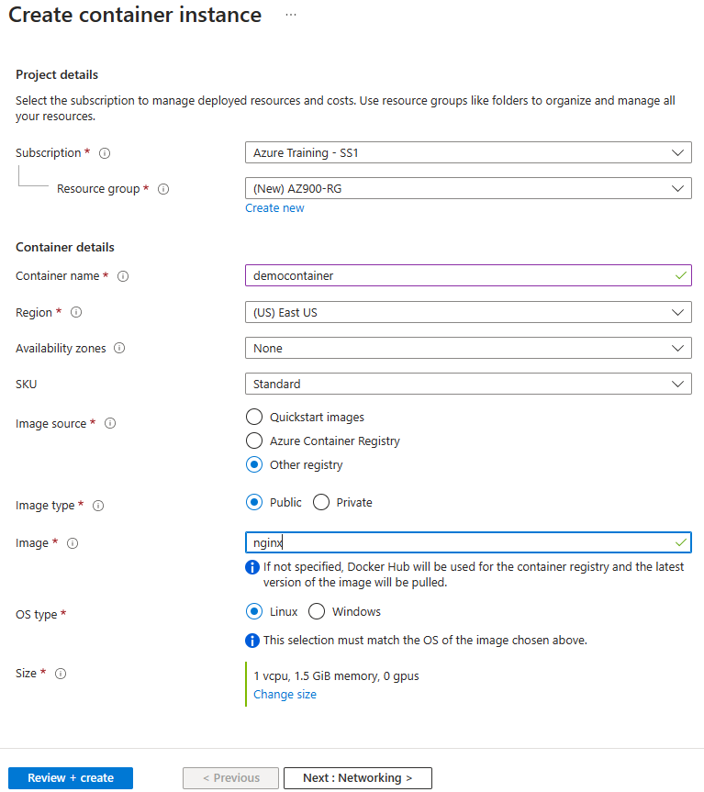

🡪 Review + create 🡪 Create.

1. Copy IP address of Container Instance
2. In Browser 🡪 visit http://<PublicIPAddressOfVM>
3. Note that you get the default page of the website.

Lab7: Create Web App using Docker image

Search 🡪 App services 🡪 + Create 🡪 +Web app

**Docker Tab**

**Lab9: Create a storage account, Create public Container upload data and access it using url.**

Create Storage Account

1. Search **Storage account** 🡪 +Create

1. Review 🡪 Create

**Create Container and Upload a file**

1. Select Storage Account 🡪 Data Storage 🡪 Container 🡪 +Container 🡪

1. Create
2. Select **public-images** container 🡪 Upload 🡪 Browse and upload a file

1. 🡪 Upload

Access the blob using url

1. Select uploaded **Blob** 🡪 Copy URL and paste in browser.

**Lab12: Use Pricing Calculator**

Refer:

<https://azure.microsoft.com/en-us/pricing/calculator/>

**Lab13: Use TCO Calculator**

1. Go to <https://azure.microsoft.com/en-us/pricing/tco/calculator/>
2. Under **Define your workloads**, select **Add server workload** to create a row for your bank of Windows Server VMs.
3. Under **Servers**, set the value for each of these settings:

|  |  |
| --- | --- |
| **Setting** | **Value** |
| Name | **Servers: Windows VMs** |
| Workload | **Windows/Linux Server** |
| Environment | **Virtual Machines** |
| Operating system | **Windows** |
| Operating System License | **Datacenter** |
| VMs | **50** |
| Virtualization | **Hyper-V** |
| Core(s) | **8** |
| RAM (GB) | **16** |
| Optimize by | **CPU** |
| Windows Server 2008/2008 R2 | **Off** |

1. Select **Add server workload** to create a second row for your bank of Linux VMs. Then specify these settings:

|  |  |
| --- | --- |
| **Setting** | **Value** |
| Name | **Servers: Linux VMs** |
| Workload | **Windows/Linux Server** |
| Environment | **Virtual Machines** |
| Operating system | **Linux** |
| VMs | **50** |
| Virtualization | **VMware** |
| Core(s) | **8** |
| RAM (GB) | **16** |
| Optimize by | **CPU** |

1. Under **Storage**, select **Add storage**. Then specify these settings:

|  |  |
| --- | --- |
| **Setting** | **Value** |
| Name | **Server Storage** |
| Storage type | **Local Disk/SAN** |
| Disk type | **HDD** |
| Capacity | **60 TB** |
| Backup | **120 TB** |
| Archive | 1. **TB** |

1. Under **Networking**, set **Outbound bandwidth** to **15 TB**.
2. Select **Next**.

**Adjust assumptions**

Here, you specify your currency. For brevity, you leave the remaining fields at their default values.

In practice, you would adjust any cost assumptions and make any adjustments to match your current on-premises environment.

1. At the top of the page, select your currency. This example uses **US Dollar ($)**.
2. Select **Next**.

**View the report**

Take a moment to review the generated report.

Remember, you've been tasked to investigate cost savings for your European datacenter over the next three years.

To make these adjustments:

1. Set **Timeframe** to **3 Years**.
2. Set **Region** to **East US**.

**Lab15: Create Azure Policy to allow resource creation only in particular region**

1. Search Policy
2. Assignment 🡪 Assign policy
3. Click … for Policy definition 🡪 Search location 🡪 Select **Allowed locations 🡪 Add**

1. Skip advanced tag
2. Parameters Tab 🡪 Allowed Locations: Select East US and East US2

1. Non-compliance message 🡪 This location not allowed 🡪 Review+Create 🡪 Create 🡪 Assign Policy.
2. Try creating a storage account in any other region and note the error…

**Lab16: Create Resource Lock for Storage Account**

Refer:

<https://docs.microsoft.com/learn/modules/describe-features-tools-azure-for-governance-compliance/5-exercise-configure-resource-lock>